 YUI Library: Slider 2011-3-21 v2.9
 |  | YAHOO.widget.Slider: Factory Methods  getHorizSlider()  getVertSlider()  getSliderRegion()  Each method returns a Slider object. See Constructor section for args list.  YAHOO.widget.Slider: Properties  animate (b)  animationDuration (n) default 0.2, roughly in seconds  keyIncrement (n) number of pixels to move slider on arrow keypress  YAHOO.widget.Slider: Methods  getValue()  getXValue()  getYValue()  lock()  setRegionValue(int newXOffset, int newYOffset, b skipAnimation)  setValue(int newOffset, b skipAnimation)  unlock()  CSS Notes:  - Slider background should be position:relative;  - Slider thumb should be position:absolute;  - Slider thumb image should not be a background image  - Alternately use Slider’s skin CSS file for default appearance. (see online docs)
  Simple Use Case
  Markup:
  <div id="sliderbg">
  <div id="sliderthumb"><img src="thumbimg"></div>
  </div>
  Script:
  var slider = YAHOO.widget.Slider.getHorizSlider("sliderbg", "sliderthumb", 0, 200);
  Creates a horizontal Slider within the sliderthumb div that can move 0 pixels left and 200 pixels to the right.
  Constructor: YAHOO.widget.Slider
  YAHOO.widget.Slider.getHorizSlider(str bgid, str thumbid, int lft/up, int rt/dwn[, int tick]);
  Arguments for Horizontal and Vertical Sliders:
  (1) Background element ID: HTML ID for the slider’s background.
  (2) Thumb element ID: HTML ID for the thumb element.
  (3) Left/Up: The number of pixels the thumb can move left or up.
  (4) Right/Down: The number of pixels the thumb can move right or down.
  (5) Tick interval: Number of pixels between each tick mark.
  Region Sliders take four args for range: left, right, up, down.
  Solutions
  Create a vertical Slider with a range of 300 pixels, ticks at 10 px intervals, and an initial value of 160:
  var slider = YAHOO.widget.Slider.getVertSlider("sliderbg", "sliderthumb", 0, 300, 10);
  slider.setValue(160, true); //set to 160, skip anim
  Create a 300x400 pixel region Slider and set the initial thumb position to 263 on the x-axis and 314 on the y-axis:
  var slider = YAHOO.widget.Slider.getSliderRegion("sliderbg", "sliderthumb", 0, 300, 0, 400);
  slider.setRegionValue(263, 314, true);
  Assuming an instance of a horizontal Slider in variable mySlider, write a handler for its onSlideEnd event:
  mySlider.subscribe("slideEnd", function() {
  alert(this.getValue()); //alerts offset from start
  });
  Interesting Moments in Slider see online docs for complete list
  Event | Fires... | Arguments
  slideStart | ...at the beginning of a user-initiated change in the thumb position. | none
  slideEnd | ... at the end of a user-initiated change in the thumb position. | none
  change | ...each time the thumb position changes during a user-initiated move. | int or {x: int, y:int} offset from the starting position, one offset per slider dimension
  Slider events are Custom Events; subscribe to them by name using the following syntax: mySlider.subscribe("change", fn);.
  Slider Design Considerations
  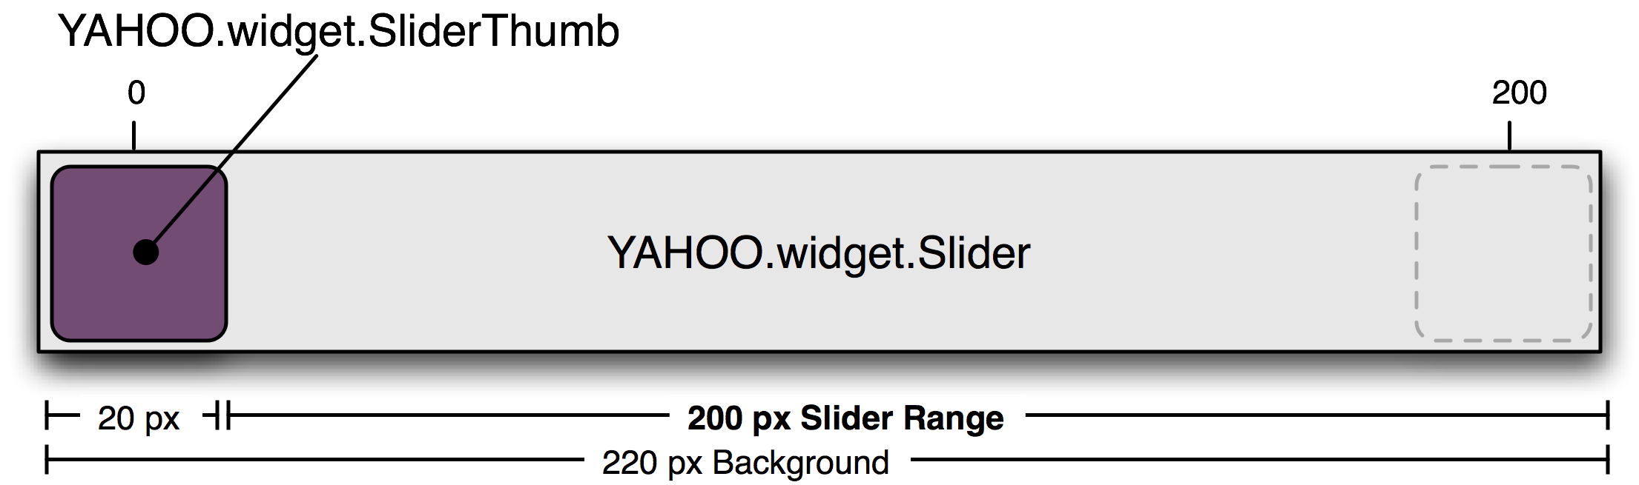
  A Slider is an implementation of a "finite range control." The range defined by the Slider is incremented in pixels. The max range of a Slider is the pixel-width of the Slider's background minus the width of the Slider Thumb.
  Region Sliders:
  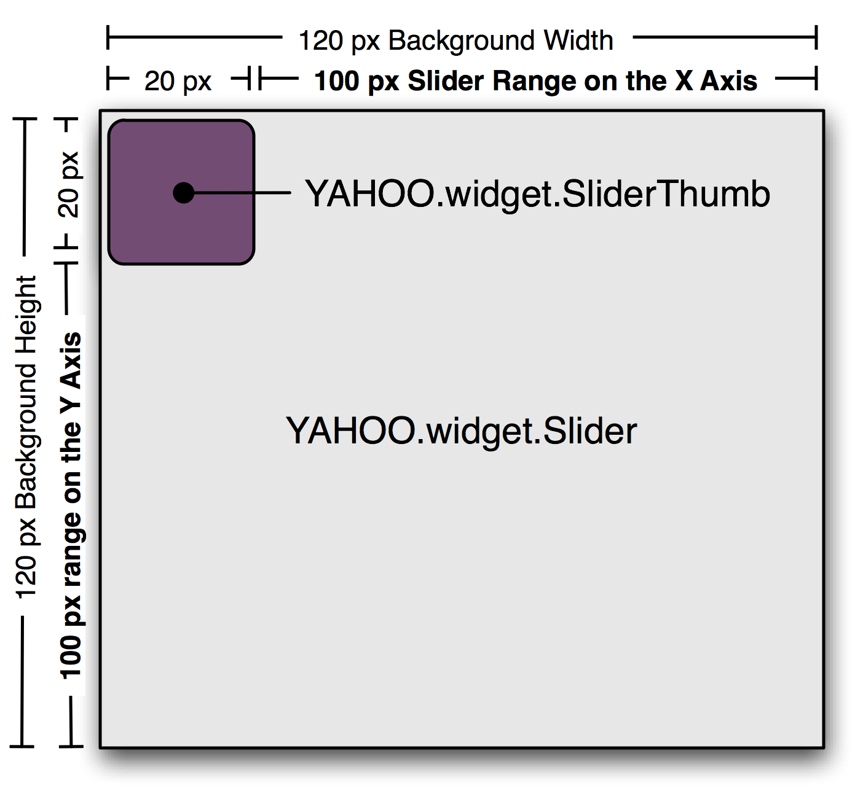
  A two-dimensional Slider is referred to as a Region Slider. Region Sliders report two values onChange (x offset, y offset) and have their own method for setting value in JavaScript: setRegionValue takes x offset and y offset as arguments, followed by the boolean flag for skipping animation. Design considerations regarding range and thumb width apply in both vertical and horizontal dimensions.
  Dependencies
  Slider requires the YAHOO object, Event, Drag & Drop, Dom, and (optionally) Animation.

