 YUI Library: Slider with Dual Thumbs 2011-3-21 v2.9
 |  | YAHOO.widget.Slider: Factory Methods  getHorizDualSlider()  getVertDualSlider()  Each method returns a DualSlider object. See Constructor section for args list.  YAHOO.widget.DualSlider: Properties  minVal (n) (read only)  maxVal (n) (read only)  isHoriz (b) (read only)  minSlider (Slider) (read only)  maxSlider (Slider) (read only)  minRange (n) (read / write)  minimum number of pixels the inner edges of the thumbs can be apart  YAHOO.widget.DualSlider: Methods  setMinValue(int)  setMaxValue(int)  setValues(int newMinOffset,  int newMaxOffset,  b skipAnimation)  YAHOO.widget.DualSlider:  Dependencies  DualSlider requires the YAHOO object, Dom, Event, Drag & Drop, and (optionally) Animation.  CSS Notes:  - DualSlider background should be position:relative;  - Slider thumbs should be position:absolute;  - Slider thumb image should not be a background image
  Simple Use Case
  Markup:
  <div id="sliderbg">
  <div id="minthumb"><img src="thumbimg"></div>
  <div id="maxthumb"><img src="thumbimg"></div>
  </div>
  Script:
  var slider = YAHOO.widget.Slider.getHorizDualSlider(
  “sliderbg","minthumb",“maxthumb”, 200);
  Creates two thumbs (minthumb and maxthumb) that can move within a horizontal 200 pixel range on a slide background (slidebg).
  Constructor: YAHOO.widget.DualSlider
  YAHOO.widget.Slider.getHorizDualSlider(str bgid,
  str minthumbid, str maxthumbid, int range[, int tick[,array initVals]]]);
  Arguments for Horizontal and Vertical DualSliders:
  (1) Background element ID: HTML ID for the slider’s background.
  (2) Min Thumb element ID: HTML ID for the thumb element representing the lower value.
  (3) Max Thumb element ID: HTML ID for the thumb element representing the upper value.
  (4) Range: The maximum pixel offset for the Max Thumb.
  (5) Tick interval: Number of pixels between each tick mark.
  (7) Initial Values: Array containing the desired Min Thumb and Max Thumb pixel offsets to assign during instantiation.
  Solutions
  Create a vertical DualSlider with a 300 pixel range, ticks at 10 px intervals, and initial values of 160 and 220:
  var slider = YAHOO.widget.Slider.getVertDualSlider("sliderbg", "minthumb", “maxthumb”, 300, 10, [160,220] );
  Assuming an instance of a DualSlider in variable mySlider, write a handler for its change event:
  mySlider.subscribe("change", function() {
  alert(“MIN: “+this.minVal+” MAX: “+this.maxVal);
  });
  Interesting Moments in DualSlider see docs for full list
  Event | Fires... | Arguments
  slideStart | ...at the beginning of a user-initiated change in either thumb position. | Slider instance  Slider instance housing the active thumb
  slideEnd | ... at the end of a user-initiated change in either thumb position. | Slider instance  Slider instance housing the active thumb
  change | ...each time either of the thumbs’ positions change during a user-initiated move. | DualSlider instance
  DualSlider events are Custom Events; subscribe to them by name using the following syntax: mySlider.subscribe("change", fn);.
  DualSlider Design Considerations
  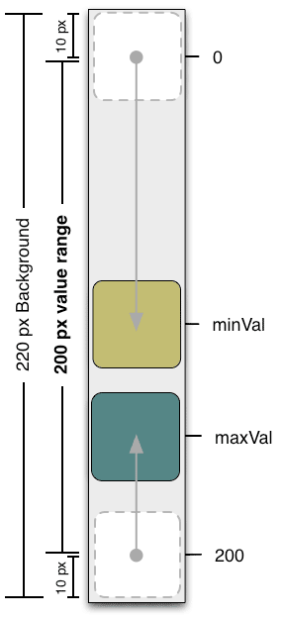 | DualSlider is an implementation of a "finite range control." The range defined by the DualSlider thumbs is expressed in pixels.  The maximum range of a slider is the pixel-width of the DualSlider's background minus half the width of the Min Thumb minus half the width of the Max Thumb.  Values for each thumb are calculated according to their center point. To quantify the space between the thumbs, use this formula:  innerDiff = maxVal - minVal -  (maxThumbWidth/2) -  (minThumbWidth/2)

