 YUI Library: ProfilerViewer Control 2011-3-21 v2.9
 |  | YAHOO.widget. ProfilerViewer Properties  STRINGS static member containing strings used in the UI; see API docs for the format of this object and examples for how to use this object to internationalize your ProfilerViewer console.  YAHOO.widget. ProfilerViewer Methods  getBodyEl() returns the element containing the console body (chart and table)  getChart() returns the Chart Control instance (if present)  getChartEl() returns the element containing the Chart Control and legend  getDataTable() returns the DataTable Control instance  getHeadEl() returns the element containing console header and buttons  getTableEl() returns the element containing DataTable’s DOM structure.  refreshData() programmatically refreshes the data in the console
  Simple Use Case: Profiling an Object
  //assuming you have an object with functions called “myObject”:
  YAHOO.tool.Profiler.registerObject("myObject", myObject); //see Profiler docs for more on how
  //to set up your code profiles.
  var pv = new YAHOO.widget.ProfilerViewer(“myEl”);
  This code tells the Profiler to profile myObject and tells ProfilerViewer to create a viewer display in the DOM element whose id is myEl. ProfilerViewer will show all profiled functions; use the filter attribute to limit a viewer instance to a subset of profiled functions. Upon instantiation, the ProfilerViewer launcher is rendered:
  Once the View Profiler Data button is clicked, ProflierViewer will load the DataTable and Charts controls and display the viewing console. A ProfilerViewer console with default options will look like this:
  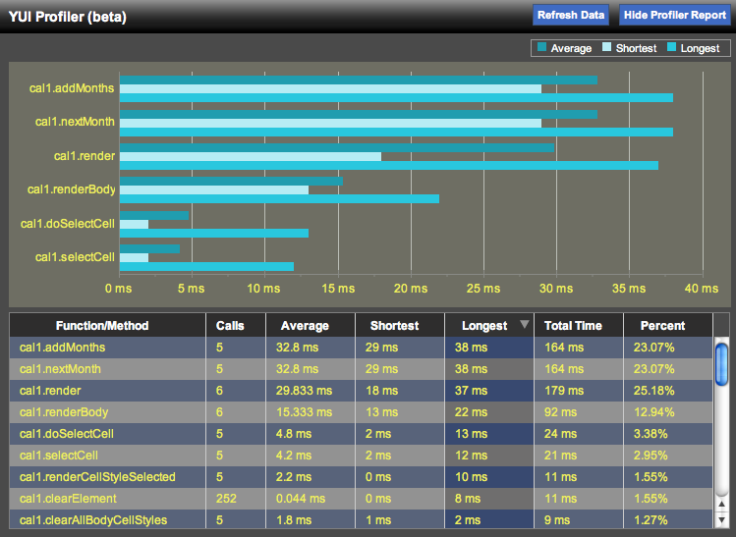
  Constructor: YAHOO.widget.ProfilerViewer
  YAHOO.widget.ProfilerViewer([str | obj container, obj configuration])
  Arguments:
  (1) Container: (Optional) A reference to a DOM element (by ID or direct reference) that will contain the ProfilerViewer display. For best results, us an element with at least 750px of viewable width. If no element is passed, a new element will be created as the first child of the <body> element.
  (2) Configuration: (Optional) An optional object containing your desired configuration options. See Configuration Options section for details.
  Key ProfilerViewer Configuration Options
  Field | Type | Description
  base | string | Path to your YUI base directory, to be used by YUI Loader in pulling in dependencies on-demand. Default: YUI files will be served from yui.yahooapis.com.
  filter | function | The filter used by ProfilerViewer in determining which profilerd functions to show in the display. See Solutions below for more.
  maxChart Functions | string | The maximum number of functions to profile in the Chart display. Default: 6.
  showChart | boolean | Determines whether or not the Chart Control should be used to visualize profiling data. Default: true.
  sortedBy | object | {key: string, dir: string} The default sort column and direction for data in the DataTable. Valid keys are: fn, calls, avg, min, max, total, pct. Valid dir values are: YAHOO.widget.DataTable.CLASS_ASC and YAHOO.widget.DataTable.CLASS_DESC.
  swfUrl | string | Relative path or url to the YUI Charts Control .swf file. Defaults to current version hosted on yui.yahooapis.com.
  tableHeight | string | Height of the DataTable portion of the console. Default: “15em”.
  visible | boolean | If true, the ProfilerViewer Console will render immediately upon instantiation. Otherwise, just the launcher will render initially. Default: false.
  Configuration options should be set in the second argument of the constructor: var pv = new YAHOO.widget.ProfilerViewer(“myEl”, {visible:true});.
  Key Interesting Moments in ProfilerViewer
  Event | Description/Fields:
  renderEvent | Event fires when the viewer canvas first renders. No arguments passed.
  refreshDataEvent | Event fires when a data refresh is requested through the UI or programmatically.
  sortedByChange | Event fires when the DataTable is resorted. Argument: {newValue: new value, oldValue: old value}.
  visibleChange | Event fires when the viewer console is shown/hidden. Argument: {newValue: new value, oldValue: old value}
  Subscribe: pv.subscribe(“visibleChange”, function(o){});.
  Solutions:
  Configure ProfilerViewer to not use the Charts Control:
  var pv = new YAHOO.widget.ProfilerViewer(“myEl”,
  showChart: false);
  Use a filter function to only display profiling data for functions that have been called at least once:
  var pv = new YAHOO.widget.ProfilerViewer(“myEl”,
  filter: function(o) {return o.calls > 0;}
  );
  Dependencies
  The ProfilerViewer Control requires the YUI Loader (which includes the Yahoo Global Object and the Get Utiltiy), Dom Collection, Event Utility, Profiler, and Element Utility. (The DataTable Control and Charts Control are brought in dynamically by YUI Loader when the ProfilerViewer UI is first made visible.)

