 YUI Library: Menu 2011-3-21 v2.9
 |  | YAHOO.widget.Menu: Properties  parent  element  id  YAHOO.widget.Menu:  Methods  addItem(o || s [,i])  addItems(o || s [,i])  getItem(i [,i])  getItems()  getItemGroups()  getSubmenus()  getRoot() returns root Menu  instance  insertItem(o || s [,i] [,i])  removeItem(o || i [,i])  setItemGroupTitle(s [,i])  show()  hide()  clearContent()  render([el])  destroy()  YAHOO.widget.  MenuItem: Properties  element  parent  id  groupIndex  index  value  YAHOO.widget.  MenuItem: Methods  focus()  blur()
  Simple Use Case: YAHOO.widget.Menu
  Markup (optional, using standard module format):
  <div id="mymenu">
  <div class="bd">
  <ul>
  <li><a href=” … ”>item one</a></li>
  <li><a href=” … ”>item two</a></li>
  </ul>
  </div>
  </div>
  Script:
  var oMenu = new YAHOO.widget.Menu("mymenu");
  oMenu.render();
  oMenu.show();
  Creates, renders and shows a menu using existing markup.
  Constructor: YAHOO.widget.Menu
  YAHOO.widget.Menu(str elId[, obj config]);
  Arguments:
  (1) Element ID: HTML ID of the element being used to create the Menu. If this element doesn't exist, it will be created and appended to the document body.
  (2) Configuration Object: JS object defining configuration properties for the Menu instance. See Configuration section for full list.
  Three Types of Menus
  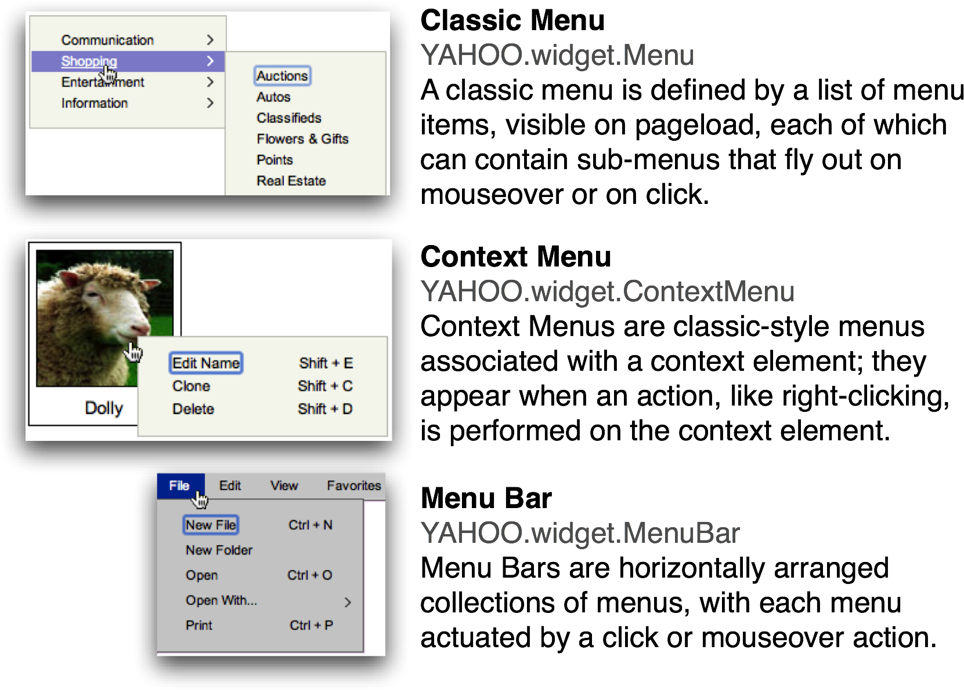
  Key Interesting Moments in Menu
  See online docs for a complete list of Menu’s Custom Events.
  itemAdded | show
  itemRemoved | hide
  render | beforeShow
  beforeRender | beforeHide
  All Menu events are YUI Custom Events (see Event Utility docs); subscribe to these events using their subscribe method: oMenu.subscribe(“show”, fnMyHandler);.
  Key Menu Configuration Options
  See online docs for complete list of Menu options.
  Option (type) | Default | Description
  constrain  toviewport (b) | true | Forces a Menu to remain inside the confines of the viewport.
  itemData (a) | null | Array of MenuItems to be added to Menu.
  lazyLoad (b) | false | Boolean value specifies whether Menu should defer initialization and rendering of submenus until needed.
  position (s) | "dynamic" (“static” for MenuBar) | Static: in the flow of the document, visible by default. Dynamic: hidden by default, outside of page flow.
  submenuhidedelay (n) | 250 | Delay (in ms) for hiding a submenu as a user mouses out of parent MenuItem while mousing toward the submenu.
  showdelay (n)/  hidedelay (n) | 250 (show),  0 (hide) | Built-in delay when showing or hiding the Menu, in miliseconds.
  trigger (s || o || a) | Null | The id(s) or node reference(s) for the element(s) whose contextmenu event triggers the context menu's display.
  maxheight (n) | 0 | The maximum height (in pixels) for a menu before the contents of the body are scrolled.
  shadow | b | Renders a Menu with a shadow.
  keepopen | b | Keeps the Menu open when clicked.
  Menu options can be set in the constructor's second argument (eg, {visible: true}) or at runtime via setProperty (eg, oMenu.cfg.setProperty("visible", false);).
  Key MenuItem Configuration Options
  See online docs for complete list of MenuItem options.
  Option (type) | Default | Description
  checked (b) | false | Renders the item with a checkmark.
  disabled (b) | false | If set to true the MenuItem will be dimmed and will not respond to user input or fire events.
  selected (b) | false | If set to true the MenuItem will be highlighted.
  submenu (o) | null | Appends a menu to the MenuItem.
  target (s) | null | Value for the "target" attribute of the item’s anchor element.
  text (s) | null | Text label for the item.
  url (s) | "#" | URL for the anchor's "href" attr.
  MenuItem options can be set in the constructor's second argument (eg, {disabled: true}) or at runtime via setProperty (eg, oMenuItem.cfg.setProperty("disabled", true);).
  Dependencies
  Menu requires the Container Core package, the YAHOO Object, Event, and Dom.
YUI Library: Menu HTML & CSS Reference Guide 2011-3-21 v2.9
