 YUI Library: Logger 2011-3-21 v2.9
 |  | YAHOO.widget.Logger Static Properties:  loggerEnabled (b)  maxStackEntries (int)  YAHOO.widget.Logger Static Methods:  log(sMsg, sCategory, sSource)  disableBrowserConsole()  enableBrowserConsole()  getStack()  getStartTime()  reset()  YAHOO.widget.Logger Custom Events:  categoryCreateEvent  sourceCreateEvent  newLogEvent  logResetEvent  LogReader Properties:  verboseOutput (b)  newestOnTop (b)  thresholdMax (int)  thresholdMin (int)  outputBuffer (int)  LogReader Methods:  hide()/show()  pause()/resume()  collapse()/expand()  clearConsole()  hideCategory()/  showCategory()  hideSource()/  showSource()  LogWriter Methods:  log(sMsg, sCategory, sSource)
  Simple Use Case (LogReader)
  <div id="myLogger"></div>
  <script>
  var myLogReader = new YAHOO.widget.LogReader("myLogger");
  </script>
  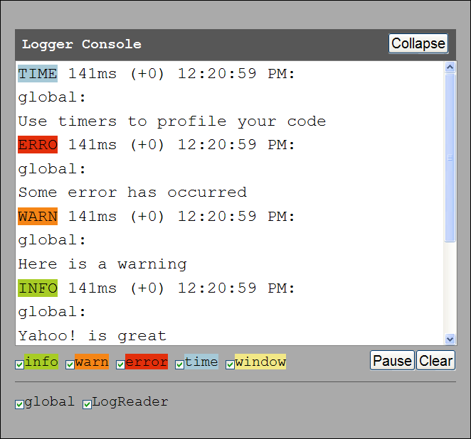
  Instantiates a new LogReader object, myLogReader, which is bound to a div whose id attribute is 'myLogger'. The result will be a visual LogReader display.
  To create a LogReader that floats outside the page context, omit the reference to a context div. Your LogReader will then be appended to the page and positioned absolutely. If the YUI Drag & Drop Library is included on the page, it will be draggable.
  Constructor (LogReader)
  YAHOO.widget.LogReader([str html id | obj element reference, obj configuration object]);
  Arguments:
  (1) HTML element (string or object): An optional reference to an HTML id string or element object binds the LogReader to an existing page element.
  (2) Configuration object (object): An optional object literal defines LogReader settings. All properties of a LogReader instance can be set via the constructor by using this object.
  Logging via console.log()
  A growing number of browsers and extensions support the JavaScript method console.log(). The excellent FireBug extension to FireFox supports this method, as does the JavaScript console in Apple's Safari browser. Enable this feature using Logger's enableBrowserConsole() method.
  Dependencies
  Logger requires the YAHOO object, Dom, and Event; Drag & Drop is optional. Use in combination with –debug versions of YUI files for built-in logging from components.
  Simple Use Case (Logger)
  YAHOO.log("My log message", "error", "mysource");
  Logs a message to the default console and to console.log(), if enabled; the source is "mysource" and the category is "error". Custom categories and sources can be added on the fly.
  Constructor (LogWriter)
  Creates a separate, named bucket for your log messages:
  YAHOO.widget.LogWriter(str sSource);
  Arguments:
  (1) Source (string): The source of log messages. The first word of the string will be used to create a LogReader filter checkbox. The entire string will be prepended to log messages so they can be easily tracked by their source.
  Solutions
  Log a message using a pre-styled logging category:
  YAHOO.log("My log message.", "warn");
  Create a new logging category on the fly:
  YAHOO.log("My log message.", "myCategory");
  Style a custom logging category in CSS:
  .yui-log .myCategory {background-color:#dedede;}
  Log a message, creating a new "source" on the fly:
  YAHOO.log("My log message.", "warn", "newSource");
  In script, hide and show the logging console:
  myLogReader.hide();
  myLogReader.show();
  In script, pause and resume output to the console:
  myLogReader.pause();
  myLogReader.resume();
  Instantiate your own LogWriter to write log messages categorized by their source:
  MyClass.prototype.myLogWriter = new YAHOO.widget.LogWriter("MyClass of MyApp");
  var myInstance = new MyClass();
  myInstance.myLogWriter.log("This log message can now be filtered by its source, MyClass."); //"MyClass of MyApp", the full name of the source, will be prepended to the actual log message
  Categories
  info  warn  error  time  window | (Pass in other categories to log() to add to this list.)

