 YUI Library: Browser History Manager 2011-3-21 v2.9
 |  | YAHOO.util.History Methods:  getBookmarkedState(str module) returns str bookmarked state  getCurrentState(str module) returns str current state  getQueryStringParameter(str param name[, str query string]) returns str param value  initialize(str stateFieldId, str histFrameId)  navigate(str module, str state) returns Boolean success  multiNavigate(arr states) returns Boolean success  register(str module, str initial state, fn callback[, obj associated object, b scope])
  Getting Started with Browser History Manager
  1. Required Markup
  The Browser History Manager requires the following in-page markup:
  <iframe id="yui-history-iframe" src="asset"></iframe>
  <input id="yui-history-field" type="hidden">
  - The asset loaded in the IFrame must be in the same domain as the page (use a relative path for the src attribute to make sure of that)
  - The asset loaded in the IFrame does not have to be an HTML document. It can be an image for example (if you use an image that you also happen to use in your page, you will avoid an unnecessary round-trip, which is always good for performance)
  - This markup should appear right after the opening <body tag.
  2. Module Registration and the register Method
  Use the following code to register a module:
  YAHOO.util.History.register(str module, str initial state, fn callback[, obj associated object, b scope])
  Arguments:
  - module: Arbitrary, non empty string identifying the module.
  - Initial state: Initial state of the module (corresponding to its earliest history entry). YAHOO.util.History.getBookmarkedState may be used to find out what this initial state is if the application was accessed via a bookmark.
  - callback: Function that will be called whenever the Browser History Manager detects that the state of the specified module has changed. Use this function to update the module’s UI accordingly.
  - associated object: Object to which your callback will have access; often the callback’s parent object.
  - scope: Boolean – if true, the callback runs in the scope of the associated object.
  3. Using the onReady Method
  Once you’ve registered at least one module, you should use the Browser History Manager's onReady method. In your handler, you should initialize your module(s) based on their current state. Use the function YAHOO.util.History.getCurrentState to retrieve the current state of your module(s).
  YAHOO.util.History.onReady(function () {
  var currentState = YAHOO.util.History.getCurrentState("module");
  // Update UI of module to match current state
  });
  4. Initializing the Browser History Manager
  Before using the Browser History Manager, you must initialize it, passing in the id of the required HTML elements created in step 1:
  YAHOO.util.History.initialize("yui-history-field", "yui-history-iframe");
  Storing New History Entries: The navigate Method
  Any registered module can create a new history entry at any time. Doing so creates a new “stop” to which the user can navigate to via the back/forward buttons and that can be bookmarked in the browser. You can create new history entries in your script using the navigate method.
  YAHOO.util.History.navigate(str module, str new state);
  Arguments:
  - module: Module identifier you used when you registered the module.
  - new state: String representing the new state of the module.
  Note: The navigate method returns a Boolean indicating whether the new state was successfully stored.
  Note: The multiNavigate method allows you to change the state of several modules at once, creating a single history entry, whereas several calls to navigate would create several history entries.
  A Sample Interaction
  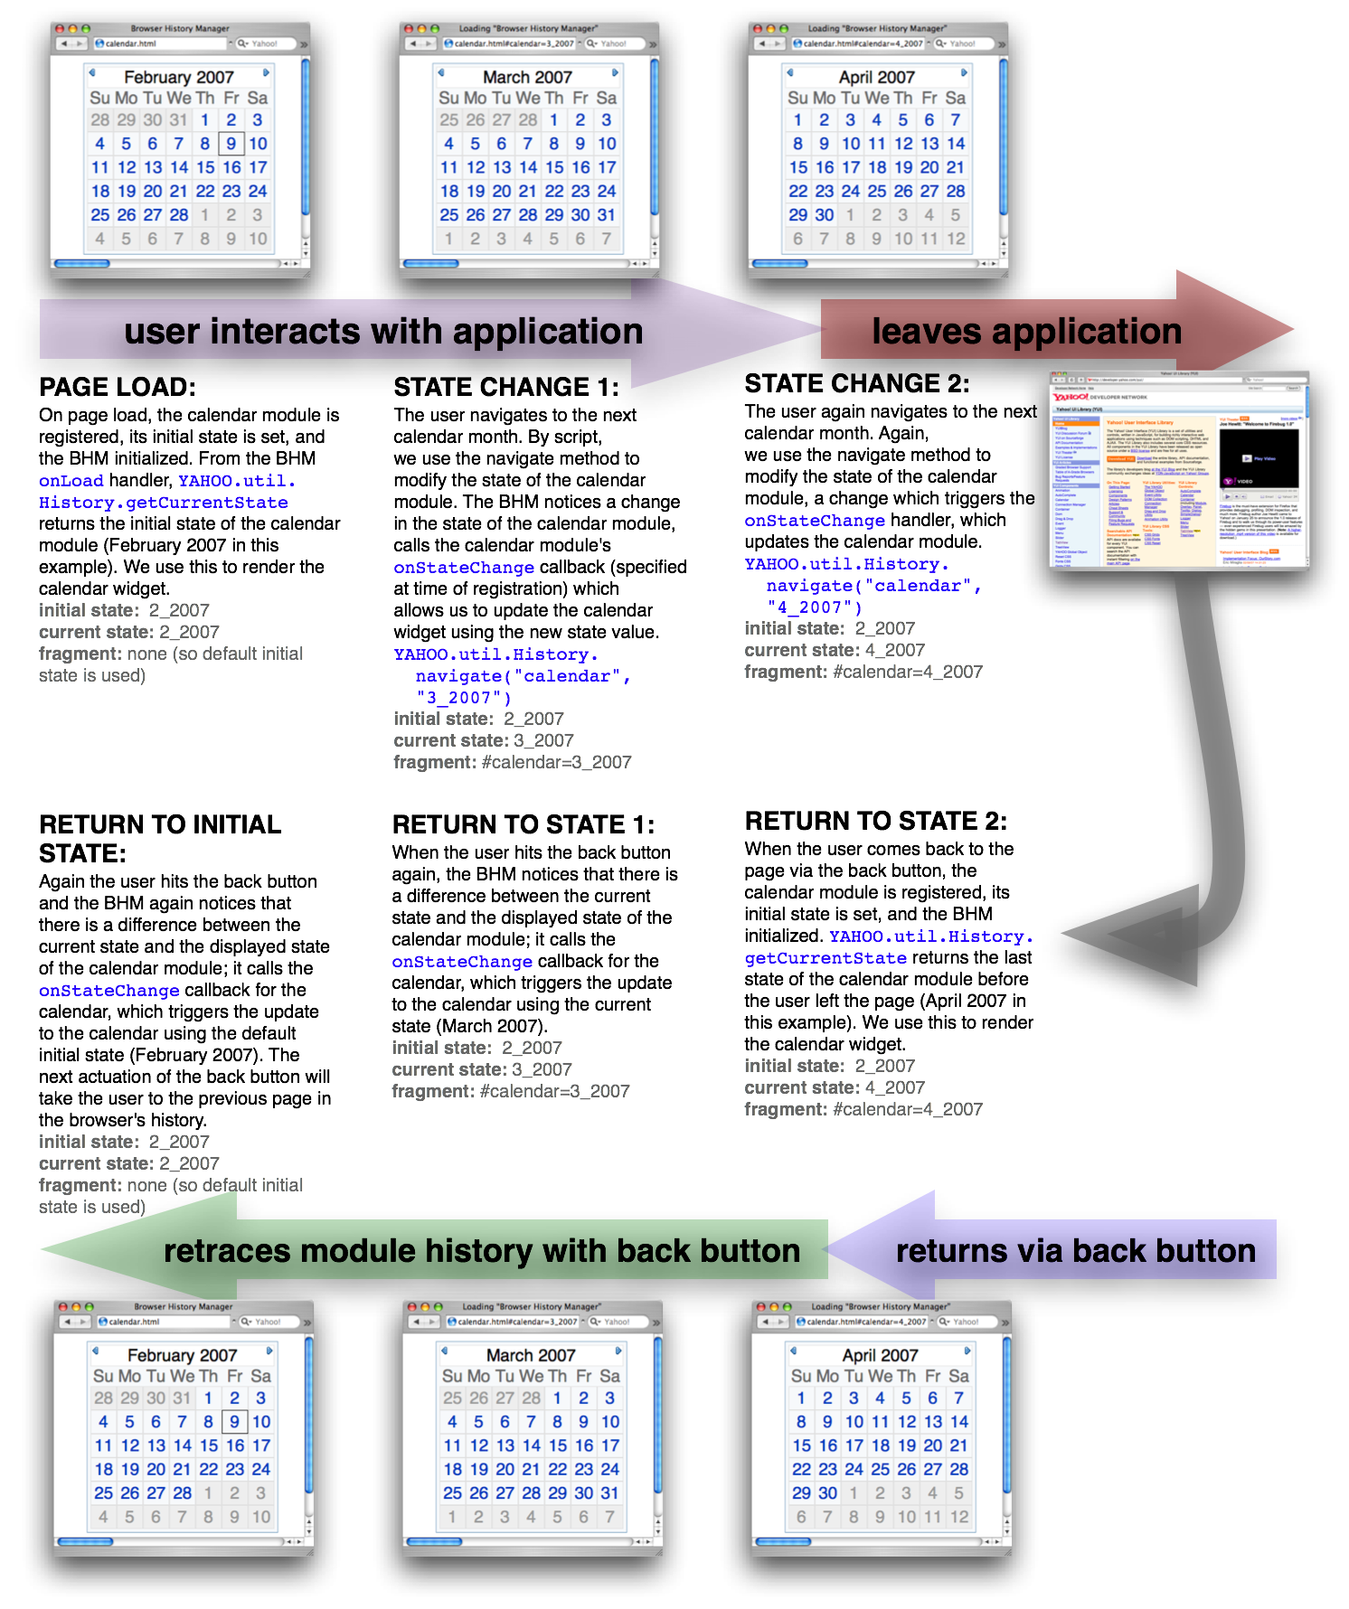
  Dependencies
  Browser History Manager requires the YAHOO Global Object and the Event Utility.

